Antigneous Instruction Manual
Written by Lexzach
What is this?
Antigneous is an affordable, open-source fire alarm control panel (FACP). This is targeted towards hobbyists or areas that do not have the privilege of having an fire alarm system from a name-brand company.
Disclaimer!
Antigneous is not officially approved for use as a fire alarm system. Although the creator has done everything they can to make sure the panel will work with zero issues, this cannot be guaranteed without extensive testing by official parties. If you do not accept the inherent risk of using a non-approved, homemade fire alarm system. DO NOT USE THIS.

Table of Contents
Getting Started 2
What you need: 2
Flashing the firmware 3
1. Download the Antigneous firmware from the GitHub. 3
2. Download the Arduino IDE 3
3. Add the ESP32 board definitions to Arduino IDE 3
4. Install the ESP32 board 4
5. Open the Antigneous firmware and Install the Liquid Crystal I2C library 4
6. Select your board 5
7. Select your port 5
8. Flash the firmware 5
Fail-safe Mode 5
Error Codes 6

Getting Started

What you need:
REQUIRED - OPTIONAL
Hardware:
- Wires
- DOIT ESP32 Dev Kit V1 (or other compatible board, but not guaranteed to work) [x1]
- Micro USB cable for programming and powering the board [x1]
- 16x2 LCD screen with IC2 interface [x1]
- LEDs [x3]
- Momentary push buttons [x3]
- Arduino compatible relays [x3]
- Piezoelectric buzzer [x1]
Software:
- A copy of the Antigneous firmware
- Arduino IDE
- ESP32 board definitions
- LiquidCrystal I2C library

Flashing the firmware

1. Download the Antigneous firmware from the GitHub.
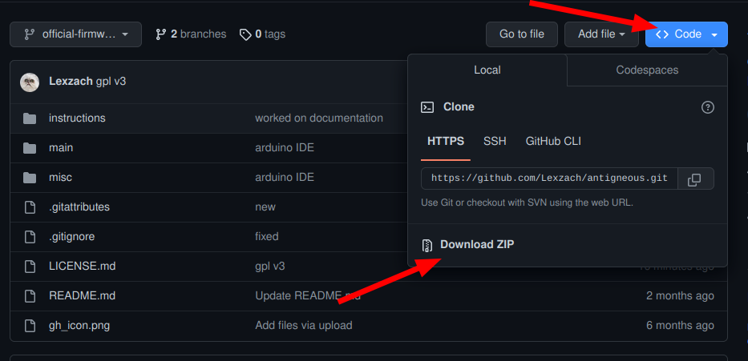
If you are a hobbyist and wish to tinker with the firmware, and you want more recent builds, click the “code” button, then download as ZIP.

People who don’t want to experiment with the firmware or need reliability should download the firmware from the releases.

2. Download the Arduino IDE
Navigate to the Arduino website in your web browser of choice, and download Arduino IDE.

3. Add the ESP32 board definitions to Arduino IDE
Navigate to File → Preferences, and paste
https://raw.githubusercontent.com/espressif/arduino-esp32/gh-pages/package_esp32_index.json
into the box labeled “Additional boards manager URLs”

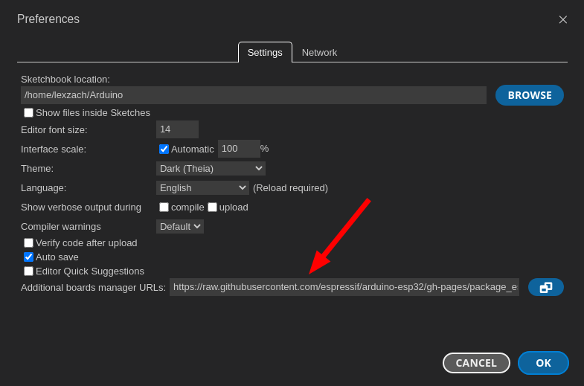

4. Install the ESP32 board
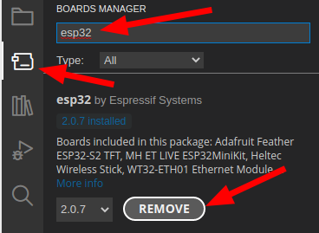
Navigate to the board manager, and type in “esp32”
Install the board by “Espressif Systems.”

5. Open the Antigneous firmware and Install the Liquid Crystal I2C library
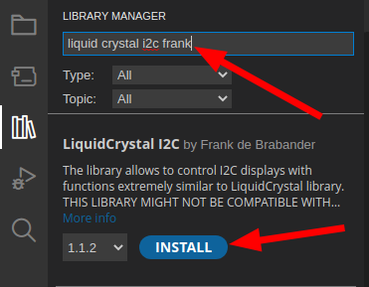
Navigate to the folder in which you downloaded the Antigneous firmware. Open the firmware file labeled “main.ino” inside the “main” folder.
Once opened, navigate to Sketch → Include Library → Manage Library
Type in “liquid crystal i2c frank” and install the library by “Frank de Brabander”

6. Select your board
Navigate to Tools. If you don’t see “Board: DOIT ESP32 DEVKIT V1,” you will need to navigate to Tools → Board → esp32 and click on “DOIT ESP32 DEVKIT V1.”

7. Select your port
Plug the ESP32 into your computer.
Navigate to Tools → Port
Select the port that appears. It will most likely start with “COM”


8. Flash the firmware
Click the forward arrow icon in the top left to flash the firmware to the device.

You’re Done!

Fail-safe Mode
Fail-safe mode is a specific mode included with the Antigneous panel. If your panel fails to boot, either from an error loading settings or something else. Fail-safe mode is intended to be a completely separate environment that is designed to boot up without fail. It does not require any interaction with the saved settings, and skips almost all of the boot-up code.
When the panel is in fail-safe mode, features are extremely limited. The only thing that works is the horn relay, strobe relay, smoke detector relay, silence button, and reset button. The reset button is the only thing that the user can interact with when the alarms are off, the reset button will restart the panel. When the alarms are on, the silence button can also be used to perform an audible silence. The coding on the alarms in fail-safe mode is continuous, and there is no verification or end-of-line resistor checks.
Fail-safe mode is not ideal to be in, and as the name suggests, is simply a mode that the panel can be in that ensures there is always fire detection, even if the panel is entirely unable to boot normally. Fail-safe mode should absolutely not be considered normal operation, and the reason for the panel not booting normally should be found and fixed immediately.

Error Codes
Antigneous Error Codes
Error Code | Meaning | Solutions
1 | The panel’s settings have failed a validity check and must be reset to factory settings. | Press the reset button to boot into the fail-safe mode.  Press the drill button to reset the panel to factory settings.
2 | The panel’s firmware has been updated to a new version, and must be reset to factory settings in order to add new settings into the panel EEPROM. | Press the reset button to boot into the fail-safe mode.  Press the drill button to reset the panel to factory settings.

