Antigneous Instruction Manual
Written by Lexzach
What is this?
Antigneous is an affordable, open-source fire alarm control panel (FACP). This is targeted towards hobbyists or areas that do not have the privilege of having an fire alarm system from a name-brand company.
Disclaimer!
Antigneous is not officially approved for use as a fire alarm system. Although the creator has done everything they can to make sure the panel will have extreme reliability, this cannot be guaranteed without extensive testing by official parties. If you do not accept the inherent risk of using a non-approved, homemade fire alarm system. DO NOT USE THIS.

Table of Contents
Getting Started 2
What you need: 2
Flashing the firmware 3
1. Download the Antigneous firmware from the GitHub. 3
2. Download the Arduino IDE 3
3. Add the ESP32 board definitions to Arduino IDE 3
4. Install the ESP32 board 4
5. Open the Antigneous firmware and Install the Liquid Crystal I2C library 4
6. Select your board 5
7. Select your port 5
8. Flash the firmware 5
Using your New Panel 5
Entering the menu 6
The Testing and Settings menu 6
Fire Alarm Settings 6
Panel Settings 7
Fail-safe Mode 8
Error Codes 8

Getting Started

What you need:
REQUIRED - OPTIONAL
Hardware:
- Wires
- DOIT ESP32 Dev Kit V1 (or other compatible board, but not guaranteed to work) [x1]
- Micro USB cable for programming and powering the board [x1]
- 16x2 LCD screen with IC2 interface [x1]
- LEDs [x3]
- Momentary push buttons [x3]
- Arduino compatible relays [x3]
- Piezoelectric buzzer [x1]
Software:
- A copy of the Antigneous firmware
- Arduino IDE
- ESP32 board definitions
- LiquidCrystal I2C library

Flashing the firmware

1. Download the Antigneous firmware from the GitHub.
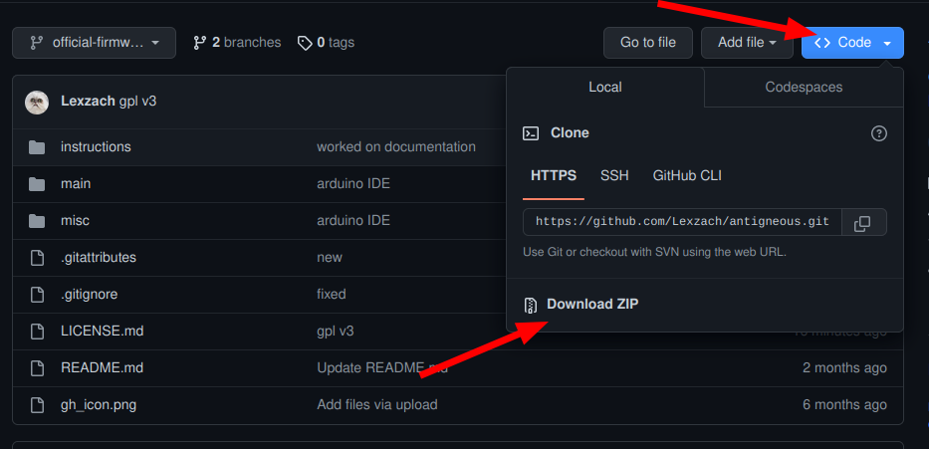
If you are a hobbyist and wish to tinker with the firmware, and you want more recent builds, click the “code” button, then download as ZIP.

People who don’t want to experiment with the firmware or need reliability should download the firmware from the releases.

2. Download the Arduino IDE
Navigate to the Arduino website in your web browser of choice, and download Arduino IDE.

3. Add the ESP32 board definitions to Arduino IDE
Navigate to File → Preferences, and paste
https://raw.githubusercontent.com/espressif/arduino-esp32/gh-pages/package_esp32_index.json
into the box labeled “Additional boards manager URLs”

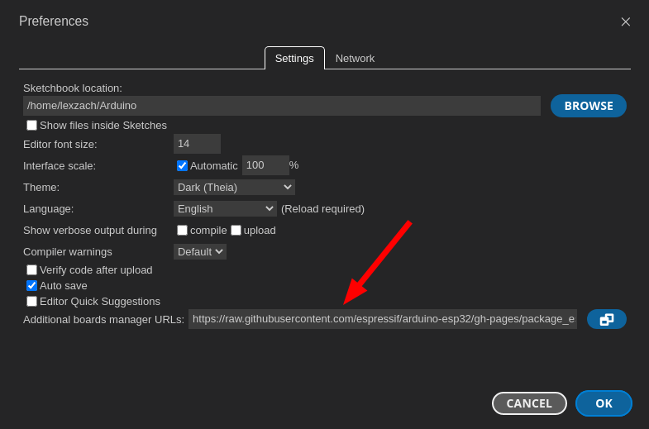

4. Install the ESP32 board
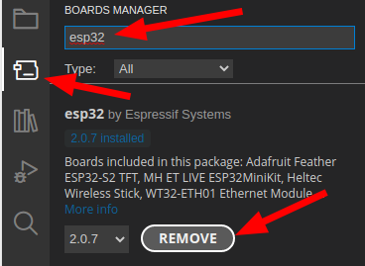
Navigate to the board manager, and type in “esp32”
Install the board by “Espressif Systems.”

5. Open the Antigneous firmware and Install the Liquid Crystal I2C library
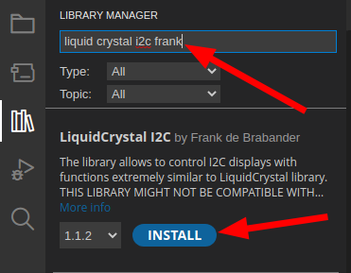
Navigate to the folder in which you downloaded the Antigneous firmware. Open the firmware file labeled “main.ino” inside the “main” folder.
Once opened, navigate to Sketch → Include Library → Manage Library
Type in “liquid crystal i2c frank” and install the library by “Frank de Brabander”

6. Select your board
Navigate to Tools. If you don’t see “Board: DOIT ESP32 DEVKIT V1,” you will need to navigate to Tools → Board → esp32 and click on “DOIT ESP32 DEVKIT V1.”

7. Select your port
Plug the ESP32 into your computer.
Navigate to Tools → Port
Select the port that appears. It will most likely start with “COM”

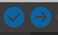
8. Flash the firmware
Click the forward arrow icon in the top left to flash the firmware to the device.

You’re Done!

Using your New Panel
Congratulations! You now have an Antigneous panel. But what do you do next?
You need to configure the panel to work best with your setup. You also want to familiarize yourself with the interface.

Entering the menu
By default, just-flashed Antigneous panels have no electronic lock to prevent tampering. This can, of course, be enabled later. But for now you may find it easier to keep the lock off until you are done setting up the panel.
You can enter the menu by pressing the silence button.
From this menu, you can control the operation of the panel.

The controls to navigate the menu are as follows:
Silence – Return to previous screen
Reset – Scroll through current screen
Drill – Enter sub-menu OR perform action such as changing a setting

The Testing and Settings menu
There are two options within the menu, testing and settings.
As the names imply, the testing menu allows you to run various tests such as walk tests, silent walk tests, and strobe tests.
The settings menu is where you can change the various panel settings.
There are two sub-menus within the settings menu, Fire Alarm and Panel.
The Fire Alarm sub-menu gives you access to settings that change how the notification appliances operate, such as the horns and strobes.

Fire Alarm Settings
Coding – Changes the audible pattern of the alarms. If you use alarms that have their own audible pattern, you may wish to use “continuous,” as this does not pulse the alarm relay.
Verification – This is a sub-menu that controls how the panel acts regarding alarm verification. In other words, how the panel double-checks to make sure a pull station is pulled or a smoke detector isn’t reporting a false alarm.
V. Time – This controls how long the panel waits before double-checking the devices to see if it should really activate the alarms.
Det. Verif. – This enables or disables smoke detector verification. In short, smoke detector verification cuts power for a specific amount of time to a smoke detector that has triggered, then waits a specified amount of time, if the smoke detector re-alarms within that set period of time, the panel goes into alarm.
Det. Timeout – This changes the amount of time that the panel cuts power to the smoke detectors after an alarm is reported.
Det. Watch – This changes how long the panel will wait for a re-alarm before resetting the verification. If the smoke detector detects smoke during this period of time, the alarms will go off. If the time elapses with no smoke detected, then the smoke detector is assumed to have reported a false alarm.
Pre-Alarm – This is a sub-menu that controls how the panel deals with pre-alarm. Pre-alarm is an alarm condition that flashes the strobes as normal, but pulses the horns in small chirps for a specified amount of time, or until the drill button is pressed.
Stage1 Time – This changes how long stage 1 will last. Stage 1 is the stage in which the horns are sounded in small chirps. After the amount of time specific here, the panel will enter stage 2, and the horns will go into full alarm, using the coding specified by the user.
Audible Sil. – This changes if the panel will keep the strobes on once the panel is silenced. If this is disabled, power is cut to both the horn and strobe relays once the silence button is pressed. If this is enabled, pressing the silence button will disable the horns, but will keep the strobes on.
No-Key Sil. – This changes if the panel is able to be silenced without a key to electronically unlock the panel. If this is enabled, the panel can be silenced if the alarms are sounding. Nothing else can be done with the panel without the key, including resetting the panel and entering the menu. This setting only allows for it to be silenced.
Strobe Sync – This changes the strobe relay to use a strobe sync pattern to sync all the strobes on a circuit.
2 Wire – This changes if the panel uses four wires or two wires for the alarms.

Panel Settings
Panel Name – This allows for a custom name to be set. This custom name displays on the home screen if no troubles or alarms are reported. Press the reset button to change the character of the selected box, then press the drill button to move forward once space. If you reach the end, the cursor will move to the beginning. Press the silence button to save and exit the panel name menu.
Panel Security – This allows the use of an electronic lock to be used. Be careful with this setting. Even though you have to reset the panel for this setting to take effect, if you enable the keyswitch lock without having a keyswitch, you will either have to install a keyswitch or factory reset the panel to regain access.
LCD Dim – This setting changes if the panel LCD will automatically dim after a specified period of time.
Factory Reset – This allows the panel to be reset to factory defaults. When you press the drill button on this option, you will have to confirm the factory reset by pressing the reset button, or you can cancel by pressing the silence button.
About – Displays information about the panel such as the firmware revision.

Fail-safe Mode
Fail-safe mode is a specific mode included with the Antigneous panel. If your panel fails to boot, either from an error loading settings or something else. Fail-safe mode is intended to be a completely separate environment that is designed to boot up without fail. It does not require any interaction with the saved settings, and skips almost all of the boot-up code.
When the panel is in fail-safe mode, features are extremely limited. The only thing that works is the horn relay, strobe relay, smoke detector relay, silence button, and reset button. The reset button is the only thing that the user can interact with when the alarms are off, the reset button will restart the panel. When the alarms are on, the silence button can also be used to perform an audible silence. The coding on the alarms in fail-safe mode is continuous, and there is no verification or end-of-line resistor checks.
Fail-safe mode is not ideal to be in, and as the name suggests, is simply a mode that the panel can be in that ensures there is always fire detection, even if the panel is entirely unable to boot normally. Fail-safe mode should absolutely not be considered normal operation, and the reason for the panel not booting normally should be found and fixed immediately.

Error Codes
Antigneous Error Codes
Error Code | Meaning | Solutions
1 | The panel’s settings have failed a validity check and must be reset to factory settings. | Press the reset button to boot into the fail-safe mode.  Press the drill button to reset the panel to factory settings.
2 | The panel’s firmware has been updated to a new version, and must be reset to factory settings in order to add new settings into the panel EEPROM. | Press the reset button to boot into the fail-safe mode.  Press the drill button to reset the panel to factory settings.

